Name of the Student: G. Manasa | Academic Year: 2024-25
Student Registration Number: 241U1R3007 | Year & Term: II&I
Study Level: UG | Class & Section: CSE-DS-2A
Name of the Course: Startup Management | Name of the Instructor: Meghana Bandi
Name of the Assessment: free writing 5 | Date of Submission: 31-08-2025

FREE WRITING 5

Prototype:
screenshots of your website and the prototype features


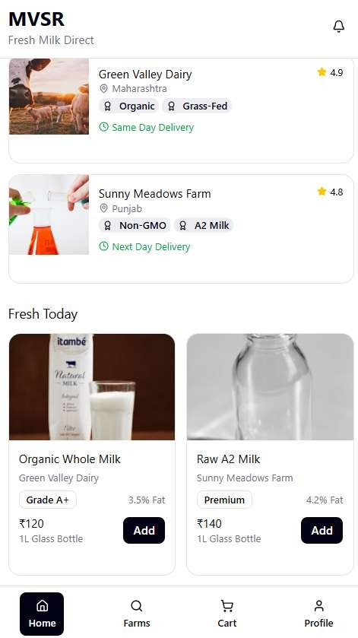





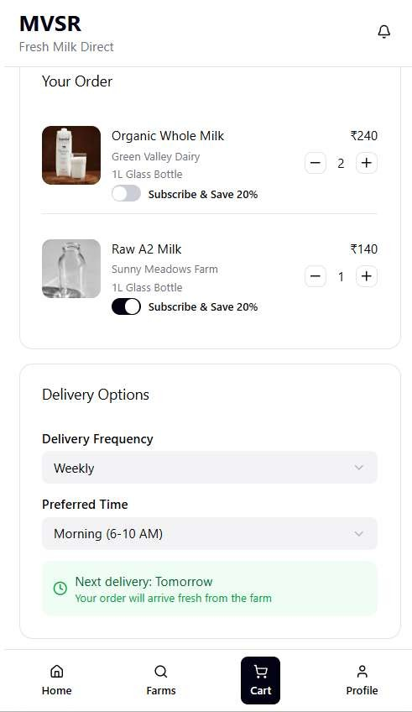

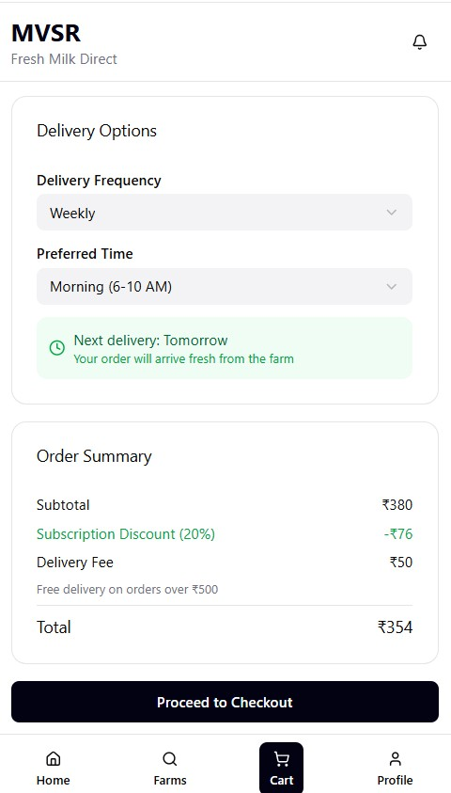

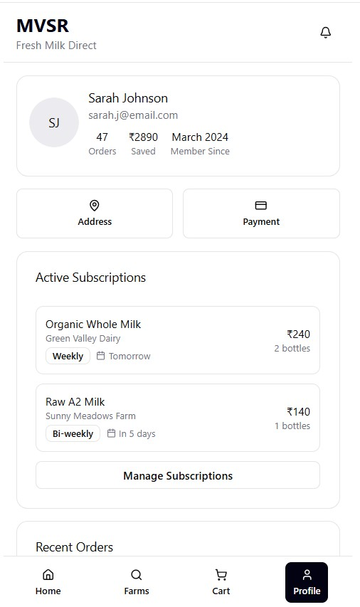

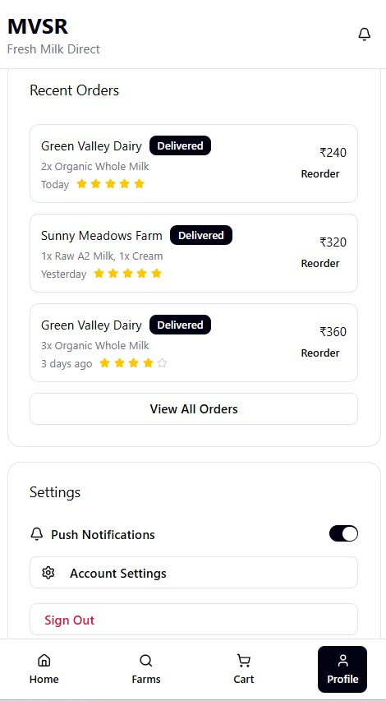

Create your company profile:

